Final report for St George’s Meadow Shropshire Hills Conservation Fund 2025-26
Name of project: St Georges Meadow
Applicant: St George’s Parochial Church Council
Project Reference: CF2526/1
In March 2025, the Shropshire Hills Conservation Fund awarded us a grant of up to £1000 towards the improvement of St George’s Meadow, an unused part of Pontesbury Cemetery, in the shadow of Pontesford Hill and Earls Hill.
The outputs for the project, as based on our application, were to:
- Cut and remove grass cuttings three times in 2025/26
- Scarify the land and sow wildflower seed
- Engage with the local community through events and activities to enjoy the site and to learn about the importance of hay meadows for biodiversity

In our interim report at the end of October 2025, we were able to report that we had:
- Had a baseline botanical survey carried out.
- Undertaken a first grass cut of the site on 7/6/25.
- Delivered a full-school assembly (200 children) at Pontesbury Primary School, highlighting the project, the importance of meadows and the Shropshire Hills National Landscape
- Led class visits to St George’s Meadow for 90 children (Reception, Y3, Y6) to identify meadow flora
- Supported an art project on meadow flora and fauna, which was displayed in St George’s Meadow during the Pontesbury Festival 27th-30th June 2025
- Publicised the project in Pontesbury News
We also held a church service in the meadow on July 13th 2025 with 19 attendees.
We claimed £443.90 of the grant at the interim stage, supported by 57 hours of volunteer time worth £1809.
The initial cut had a beneficial impact on the toughest and least species-rich areas of the site. However, due to the very dry summer in 2025, the meadow re-growth of grasses and other flora was much less than usual, which disrupted our expected timetable of three cuts throughout the annual cycle. We had expected to cut again in late summer/early autumn 2025, but this was not possible due to lack of growth. Therefore, a second cut and partial scarification took place on 21st January 2026, with yellow rattle seed sown soon after in bare areas of earth.
Areas of the site which still required raking and scarification were attended to by volunteers in February.
This project has allowed us to understand much better the different soils and growing conditions across our meadow site. In response to the unusual growing conditions over 2025-26, we decided to boost the most promising part of the meadow site with native plug plants, sourced from a local grower in Shrewsbury. 8 volunteers assisted with the planting of 400 plug plants, which are establishing successfully.
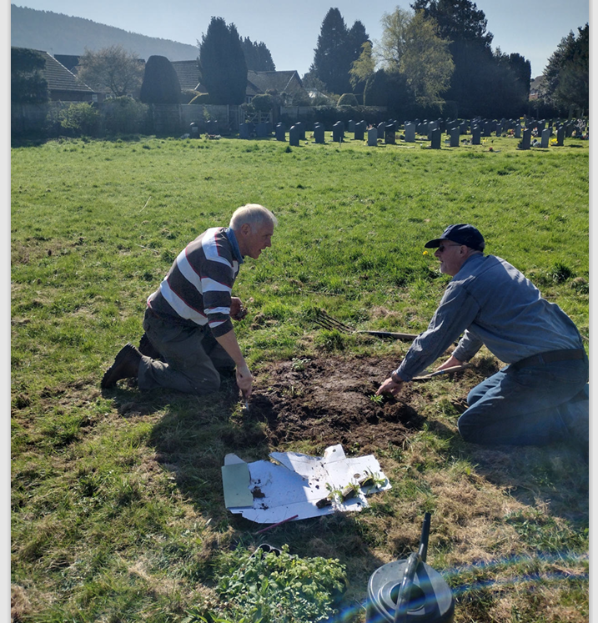
We can now give attention to the more challenging and nutrient-rich/species poor areas. We are planning a community cut for the vigorous areas of grasses, with the intention to make hay, in the next few weeks.
Our claim for the second stage of the project is £444.93 supported by 39 volunteer hours valued at £308, representing a total project claim of £888.83 with 96 volunteer hours valued at £2,117, an additional £837 of volunteer time compared with our application.
Future plans
Pontesbury Primary School children, with Pontesbury Parish Council and Pontesbury Climate Emergency Action Group, have built on our meadow project last summer by potting on meadow plants to plant out in our village greens on 2nd May.
We will be drawing up an annual management plan for St George’s Meadow to ensure that progress in 2025/26 year can be maintained and enhanced, using the nuanced treatment of different areas which this project has helped us to identify.
The next annual botanical survey will take place in June.
We will consider further interventions to improve the biodiversity of the meadow site, including tree planting.
Many thanks to the Shropshire Hills Landscape Trust for supporting the St George’s Meadow project.

